Navigation:
Self Service > Faculty Center

Page | Action(s) to be taken
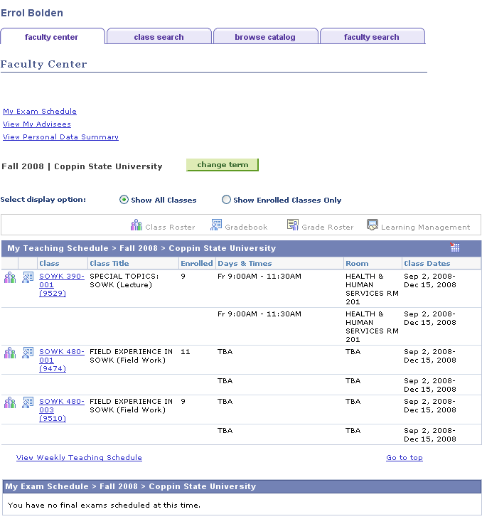 | - Click
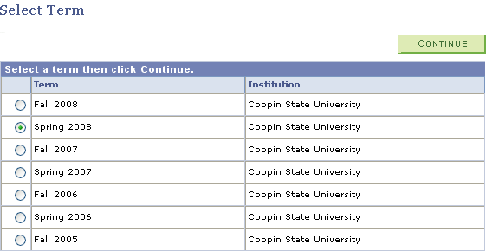 | - Select the Term for which you wish to enter your mid-term grades by pressing on the radio button beside the term in the listing.  - Click
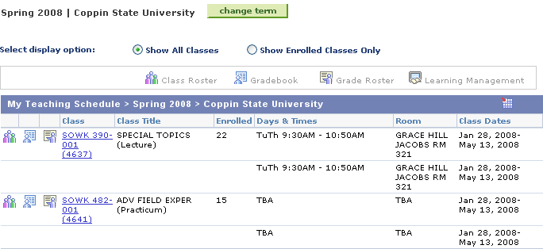 | - On the teaching schedule, click beside the class section to select the roster for which you wish to enter grades.
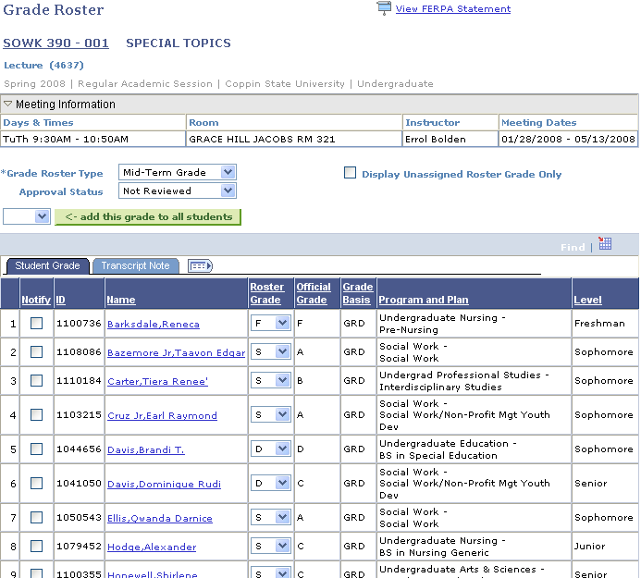   | - Select Grade Roster Type = Mid-Term Grade & Approved Status = Not Reviewed  - For subsequent updating, you can check to display only students with Unassigned Roster Grades.  - You can also indicate a grade that if you wish to .  - Select the mid-term grade from the Roster Grade drop down list in the Roster Grade column.  - Once all mid-term grades have been entered, change Approval Status to Ready for Review.  - Click  Note: The Official Grade column will display final grades once they have been posted.  - A subset or all students may be notified by pressing or .  - Click to print a Mid-Term Grade Roster. You can highlight grid contents and insert into Excel to make use of functionality in this application.  - Click

