Navigation:
Self Service > Student Center

Page | Action(s) to be taken
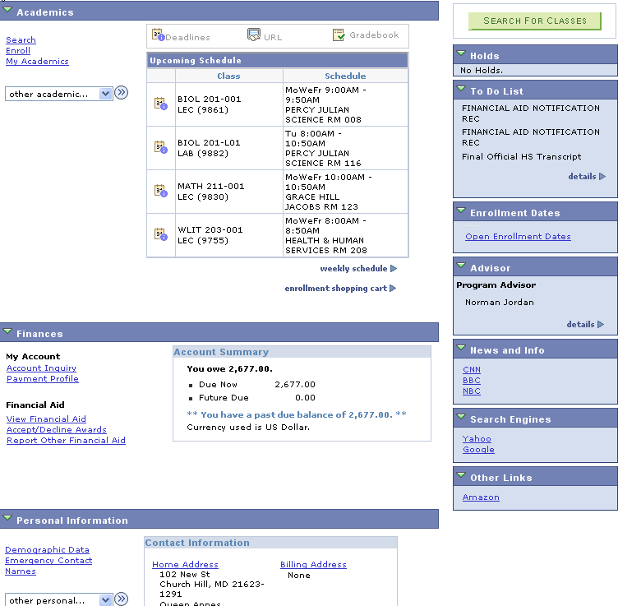 | - Click My Academics link.
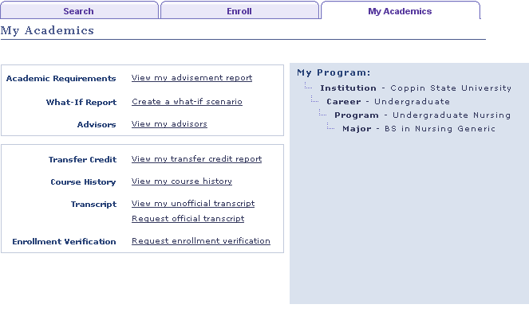 | - Click Enroll tab.
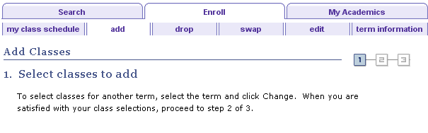 | - Select term information tab.`
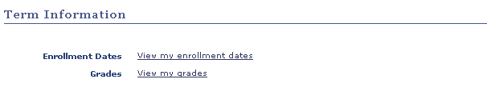 | - On the Term Information page, select
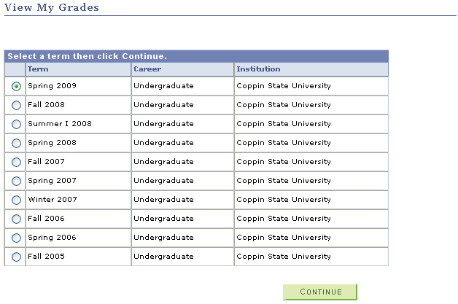 | - On the View My Grades page, select a term for which you want to review your final grades.  - Click
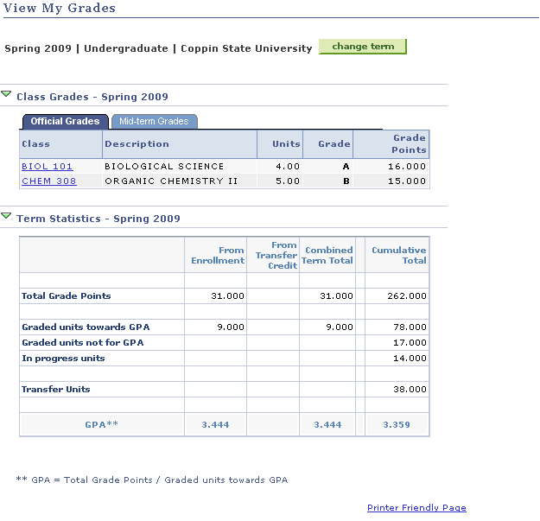 | - Click Official Grades tab to view display of these grades.  - Click to see a display of the grades and Term Statistics formatted for printing from the browser.
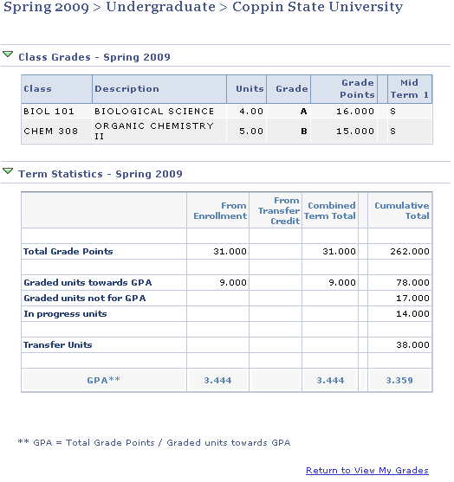 | - Printer Friendly version of grades information. Click to return to the View My Grades page.

